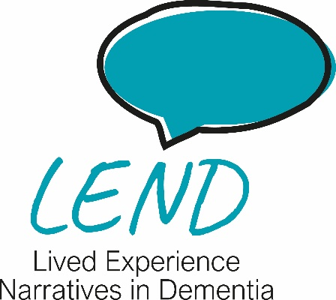
Consent

Work Package 2.3:
Feedback on the Online LEND Intervention
IRAS Project ID: 351969
v1.0 dated 22nd September 2025

Please select a tick or cross for each to show whether you agree with the following statements:
- ✔ ✗ I have read and understood the online Participant Information on the preceding pages. I have had the opportunity to consider the information, ask questions, and have had these answered to my satisfaction.
- ✔ ✗ I understand that taking part is voluntary and I can withdraw at any time without giving a reason. Data collected before withdrawal will still be used, including information like my age, ethnicity and other personal characters, linked to my responses.
- ✔ ✗ I give permission for anonymised quotes to be used in reports, presentations, or publications.
- ✔ ✗ I agree that members of the NHS sponsor or regulators may view data (under strict confidentiality) to audit and ensure the research is being conducted properly.
- ✔ ✗ I understand that all information I provide will remain confidential and will be stored securely in accordance with data protection law, including the UK General Data Protection Regulation and the Data Protection Act (2018).
- ✔ ✗ I understand confidentiality may be broken if a safeguarding concern is raised, or to comply with the law, or to comply with a Court Order.
- ✔ ✗ I agree to take part in this study.

Signature
Name in block capitals (indicating consent): _________________________

